Cognitive Process Dimension
- Revised framework includes six categories of processes, one most closely related to retention (Remember) and the other five increasingly related to transfer (Understand, Apply, Analyse, Evaluate, and Create).
- These 19 specific cognitive processes are intended to be mutually exclusive; together, they delineate the breadth and boundaries of the six categories.
- Remembering involves retrieving relevant knowledge from long-term memory. The two associated cognitive processes are recognising and recalling. The relevant knowledge may be Factual, Conceptual, Procedural, or Metacognitive, or some combination of these.
- REMEMBER
- Remembering knowledge is essential for meaningful learning and problem-solving, as that knowledge is used in more complex tasks.
- Where teachers concentrate solely on rote learning, teaching and assessing focus solely on remembering elements or fragments of knowledge, often in isolation from their context. When teachers focus on meaningful learning, however, remembering knowledge is integrated within the larger task of constructing new knowledge or solving new problems.
- 1.1 RECOGNIZING
  - Recognizing involves retrieving relevant knowledge from long-term memory in order to compare it with presented information. In recognising, the student searches long-term memory for a piece of information that is identical or extremely similar to the presented information (as represented in working memory)
  - SAMPLE OBJECTIVES AND CORRESPONDING ASSESSMENTS
    - In mathematics, an objective could be to recognise the number of sides in basic geometric shapes. A corresponding assessment is a multiple-choice test with items such as the following: "How many sides does a pentagon have? (a) four, (b) five, (c) six, (d) seven. “
  - ASSESSMENT FORMATS
    - As illustrated in the preceding paragraph, three main methods of presenting a recognition task for the purpose of assessment are verification, matching, and forced choice. In verification tasks, the student is given some information and must choose whether or not it is correct. The true-false format is the most common example. In matching, two lists are presented, and the student must choose how each item in one list corresponds to an item in the other list. In forced choice tasks, the student is given a prompt along with several possible answers and must choose which answer is the correct or "best answer." Multiple-choice is the most common format.
- 1.2 RECALLING
  - Recalling involves retrieving relevant knowledge from long-term memory when given a prompt to do so. The prompt is often a question. In recalling, a student searches long-term memory for a piece of information and brings that piece of information to working memory, where it can be processed. An alternative term for recalling is retrieving.
  - SAMPLE 0BJECTIVES AND CORRESPONDING ASSESSMENTS
    - In mathematics, an objective could be to recall the whole-number multiplication facts. A corresponding test item asks students to multiply 7 X 8 (or "7 X 8 = ?").
  - ASSESSMENT FORMATS
    - Assessment tasks for recalling can vary in the number and quality of cues that students are provided. With low cueing, the student is not given any hints or related information (such as "What is a meter?"). With high cueing, the student is given several hints (such as "In the metric system, a meter is a measure of ________ ."). Assessment tasks for recalling can also vary in the amount of embedding or the extent to which the items are placed within a larger meaningful context. With low embedding, the recall task is presented as a single, isolated event, as in the preceding examples. With high embedding, the recall task is included within the context of a larger problem, such as asking a student to recall the formula for the area of a circle when solving a word problem that requires that formula.
- UNDERSTAND
  - When the primary goal of instruction is to promote retention, the focus is on objectives that emphasize Remember. When the goal of instruction is to promote transfer, however, the focus shifts to the other five cognitive processes, “Understand” through “Create.”
  - Students are said to “understand” when they are able to construct meaning from instructional messages, including oral, written, and graphic communications; however, they are presented to students during lectures, in books, or on computer monitors. Examples of potential instructional messages include an in-class physics demonstration, a geological formation seen on a field trip, a computer simulation of a trip through an art museum, and a musical work played by an orchestra, as well as numerous verbal, pictorial, and symbolic representations on paper.
  - Students understand when they build connections between the "new" knowledge to be gained and their prior knowledge. More specifically, the incoming knowledge is integrated with existing schemas and cognitive frameworks. Since concepts are the building blocks for these schemas and frameworks, Conceptual knowledge provides a basis for understanding.
- 2. 1 INTERPRETING
  - Interpreting occurs when a student is able to convert information from one representational form to another. Interpreting may involve converting words to words (e.g., paraphrasing), pictures to words, words to pictures, numbers to words, words to numbers, musical notes to tones, and the like. Alternative terms are translating, paraphrasing, representing, and clarifying.
  - SAMPLE OBJECTIVES AND CORRESPONDING ASSESSMENTS
    - In science, an objective could be to learn to draw pictorial representations of various natural phenomena. A corresponding assessment item asks a student to draw a series of diagrams illustrating photosynthesis. In mathematics, a sample objective could be to learn to translate number sentences expressed in words into algebraic equations expressed in symbols. A corresponding assessment item asks a student to write an equation (using B for the number of boys and G for the number of girls) that corresponds to the statement "There are twice as many boys as girls in this class."
  - ASSESSMENT FORMATS
      - Appropriate test item formats include both constructed response (i.e., supply an answer) and selected response (i.e., choose an answer). Information is presented in one form, and students are asked either to construct or to select the same information in a different form. For example, a constructed response task is: "Write an equation that corresponds to the following statement, using T for total cost and P for number of pounds. The total cost of mailing a package is $2.00 for the first pound plus $1.50 for each additional pound." A selection version of this task is: "Which equation corresponds to the following statement, where T stands for total cost and P for number of pounds? The total cost of mailing a package is $2.00 for the first pound plus $1.50 for each additional pound. (a) T = $3.50 + P, (b) T = $2.00 + $1.50(P), (c) T = $2.00 + $1.SO(P - l}.“
      - To increase the probability that interpreting rather than remembering is being assessed, the information included in the assessment task must be new. "New" here means that students did not encounter it during instruction.
      - If assessment tasks are to tap higher-order cognitive processes, they must require that students cannot answer them correctly by relying on memory alone.
- 2.2 EXEMPLIFYING
  - Exemplifying occurs when a student gives a specific example or instance of a general concept or principle. Exemplifying involves identifying the defining features of the general concept or principle (e.g., an isosceles triangle must have two equal sides) and using these features to select or construct a specific instance (e.g., being able to select which of three presented triangles is an isosceles triangle). Alternative terms are illustrating and instantiating.
  - SAMPLE OBJECTIVES AND CORRESPONDING ASSESSMENTS
      - In science, a sample objective could be to be able to give examples of various kinds of chemical compounds. A corresponding assessment task asks the student to locate an inorganic compound on a field trip and tell why it is inorganic (i.e., specify the defining features).
  - ASSESSMENT FORMATS
      - Exemplifying tasks can involve the constructed response format-in which the student must create an example-or the selected response format-in which the student must select an example from a given set. The science example, "Locate an inorganic compound and tell why it is inorganic," requires a constructed response. In contrast, the item "Which of these is an inorganic compound? (a) iron, (b) protein, (c) blood, (d) leaf mold" requires a selected response.
- 2.3 CLASSIFYING
  - Classifying occurs when a student recognizes that something (e.g., a particular instance or example) belongs to a certain category (e.g., concept or principle). Classifying involves detecting relevant features or patterns that "fit" both the specific instance and the concept or principle. Classifying is a complementary process to exemplifying. Whereas exemplifying begins with a general concept or principle and requires the student to find a specific instance or example, classifying begins with a specific instance or example and requires the student to find a general concept or principle. Alternative terms for classifying are categorizing and subsuming.
  - SAMPLE OBJECTIVES AND CORRESPONDING ASSESSMENTS
      - In the natural sciences, an objective could be to learn to categorize the species of various prehistoric animals. An assessment gives a student some pictures of prehistoric animals with instructions to group them with others of the same species. In mathematics, an objective could be to be able to determine the categories to which numbers belong. An assessment task gives an example and asks a student to circle all numbers in a list from the same category.
  - ASSESSMENT FORMATS
      - In constructed response tasks, a student is given an instance and must produce its related concept or principle. In selected response tasks, a student is given an instance and must select its concept or principle from a list. In a sorting task, a student is given a set of instances and must determine which ones belong in a specified category and which ones do not or must place each instance into one of multiple categories.
- 2.4 SUMMARIZING
  - Summarizing occurs when a student suggests a single statement that represents presented information or abstracts a general theme. Alternative terms are generalizing and abstracting.
  - SAMPLE 0BJECTIYES AND CORRESPONDING ASSESSMENTS
      - A sample objective in the natural sciences could be to learn to summarize the major contributions of famous scientists after reading several of their writings. A corresponding assessment item asks a student to read selected writings about Charles Darwin and summarize the major paints. In computer science, an objective could be to learn to summarize the purposes of various subroutines in a program. An assessment item presents a program and asks a student to write a sentence describing the subgoal that each section of the program accomplishes within the overall program.
  - ASSESSMENT FORMATS
      - Assessment tasks can be presented in constructed response or selection formats, involving either themes or summaries. Generally speaking, themes are more abstract than summaries.

- 2.5 INFERRING
  - Inferring involves finding a pattern within a series of examples or instances. Inferring occurs when a student is able to abstract a concept or principle that accounts for a set of examples or instances by encoding the relevant features of each instance and, most important, by noting relationships among them. For example, when given a series of numbers such as 1, 2, 3, 5, 8, 13, 21, a student is able to focus on the numerical value of each digit rather than on irrelevant features such as the shape of each digit or whether each digit is odd or even. He or she then is able to distinguish the pattern in the series of numbers (i.e., after the first two numbers, each is the sum of the preceding two numbers).
  - The process of inferring involves making comparisons among instances within the context of the entire set. For example, to determine what number will come next in the series above, a student must identify the pattern. A related process is using the pattern to create a new instance (e.g., the next number on the series is 34, the sum of 13 and 21). This is an example of executing, which is a cognitive process associated with Apply. Inferring and executing are often used together on cognitive tasks.
  - Inferring is different from attributing (a cognitive process associated with Analyze). Attributing focuses solely on the pragmatic issue of determining the author's point of view or intention, whereas inferring focuses on the issue of inducing a pattern based on presented information. Another way of differentiating between these two is that attributing is broadly applicable to situations in which one must "read between the lines," especially when one is seeking to determine an author's point of view. Inferring, on the other hand, occurs in a context that supplies an expectation of what is to be inferred. Alternative terms for inferring are extrapolating, interpolating, predicting, and concluding.
  - SAMPLE OBJECTIVES AND C0RRESP0NDING ASSESSMENTS
      - In mathematics, an objective could be to learn to infer the relationship expressed as an equation that represents several observations of values for two variables. An assessment item asks a student to describe the relationship as an equation involving x and y for situations in which if x is 1, then y is 0; if x is 2, then y is 3; and if x is 3, then y is 8.
  - ASSESSMENT FORMATS
      - Three common tasks that require inferring (often along with implementing) are completion tasks, analogy tasks, and oddity tasks. In completion tasks, a student is given a series of items and must determine what will come next, as in the number series example above. In analogy tasks, a student is given an analogy of the form A is to B as C is to D, such as "nation" is to "president" as "state" is to ______ The student's task is to produce or select a term that fits in the blank and completes the analogy (such as "governor"). In an oddity task, a student is given three or more items and must determine which does not belong. For example, a student may be given three physics problems, two involving one principle and another involving a different principle. To focus solely on the inferring process, the question in each assessment task could be to state the underlying concept or principle the student is using to arrive at the correct answer.
- 2.6 COMPARING
  - Comparing involves detecting similarities and differences between two or more objects, events, ideas, problems, or situations. Comparing includes finding one-to-one correspondence between elements and patterns in one object, event, or idea and those in another object, event, or idea. When used in conjunction with inferring (e.g., first, abstracting a rule from the more familiar situation) and implementing (e.g., second, applying the rule to the less familiar situation), comparing can contribute to reasoning by analogy. Alternative terms are contrasting, matching, and mapping.

  - SAMPLE OBJECTIVES AND CORRESPONDING ASSESSMENTS
      - In the natural sciences, a sample objective could be to learn to compare an electrical circuit to a more familiar system. In assessment, we ask, "How is an electrical circuit like water flowing through a pipe?“
      - Comparing may also involve determining correspondences between two or more presented objects, events, or ideas. In mathematics, a sample objective could be to learn to compare structurally similar word problems. A corresponding assessment question asks a student to tell how a certain mixture problem is like a certain work problem.
      - If a student has figured out that the answer given by another student is wrong and is trying to give their version of the correct answer, he/she is using “Comparing” or “Recognize + Comparing + Evaluating”
  - ASSESSMENT FORMATS
      - A major technique for assessing the cognitive process of comparing is mapping. In mapping, a student must show how each part of one object, idea, problem, or situation corresponds to (or maps onto) each part of another. For example, a student could be asked to detail how the battery, wire, and resistor in an electrical circuit are like the pump, pipes, and pipe constructions in a water flow system, respectively.
- 2.7 EXPLAINING
  - Explaining occurs when a student is able to construct and use a cause-and-effect model of a system. The model may be derived from a formal theory often the case in the natural sciences) or may be grounded in research or experience (as is often the case in the social sciences and humanities). A complete explanation involves constructing a cause-and-effect model, including each major part in a system or each major event in the chain, and using the model to determine how a change in one part of the system or one "link" in the chain affects a change in another part. An alternative term for explaining is constructing a model.
  - SAMPLE 0BJECTIYES AND CORRESPONDING ASSESSMENTS
      - In the natural sciences, an objective could be to explain how basic physics laws work. Corresponding assessments ask students who have studied Ohm's law to explain what happens to the rate of the current when a second battery is added to a circuit or ask students who have viewed a video on lightning storms to explain how differences in temperature affect the formation of lightning.
  - ASSESSMENT FORMATS
      - Several tasks can be aimed at assessing a student's ability to explain, including reasoning, troubleshooting, redesigning, and predicting. In reasoning tasks, a student is asked to offer a reason for a given event. For example, "Why does air enter a bicycle tire pump when you pull up on the handle?" In this case, an answer such as "It is forced in because the air pressure is less inside the pump than outside" involves finding a principle that accounts for a given event.
      - In troubleshooting, a student is asked to diagnose what could have gone wrong in a malfunctioning system. For example, "Suppose you pull up and press down on the handle of a bicycle tire pump several times, but no air comes out. What's wrong?" In this case, the student must find an explanation for a symptom, such as "There is a hole in the cylinder" or "A valve is stuck in the open position."
      - In redesigning, a student is asked to change the system to accomplish some goal. For example, "How could you improve a bicycle tire pump so that it would be more efficient?" To answer this question, a student must imagine altering one or more of the components in the system, such as "Put lubricant between the piston and the cylinder."

      - In predicting, a student is asked how a change in one part of a system will affect a change in another part of the system. For example, "What would happen if you increased the diameter of the cylinder in a bicycle tire pump?" This question requires that the student "operate" the mental model of the pump to see that the amount of air moving through the pump could be increased by increasing the diameter of the cylinder
- APPLY
  - Apply involves using procedures to perform exercises or solve problems. Thus, “Apply” is closely linked with Procedural knowledge.
  - The Apply category consists of two cognitive processes: “executing”-when the task is an exercise (familiar)-and “implementing”-when the task is a problem (unfamiliar).
  - When the task is a familiar exercise, students generally know what Procedural knowledge to use. When given an exercise (or set of exercises), students typically perform the procedure with little thought. For example, an algebra student confronted with the 50th exercise involving quadratic equations might simply "plug in the numbers and turn the crank."
  - When the task is an unfamiliar problem, however, students must determine what knowledge they will use. If the task appears to call for Procedural knowledge and no available procedure fits the problem situation exactly, then modifications in selected Procedural knowledge may be necessary. In contrast to executing, then, implementing requires some degree of understanding of the problem as well as of the solution procedure. In the case of “implementing,” then, to “understand” conceptual knowledge is a prerequisite to being able to apply procedural knowledge.
- 3.1 EXECUTING
  - Executing is more frequently associated with the use of skills and algorithms than with techniques and methods. Skills and algorithms have two qualities that make them particularly amenable to “executing.” First, they consist of a sequence of steps that are generally followed in a fixed order. Second, when the steps are performed correctly, the end result is a predetermined answer. An alternative term for executing is carrying out.
  - SAMPLE OBJECTIVES AND CORRESPONDING ASSESSMENTS
      - A sample objective in elementary-level mathematics could be for students to learn to divide one whole number by another, both with multiple digits. The instructions to "divide" signify the division algorithm, which is the necessary Procedural knowledge. To assess the objective, a student is given a worksheet that has 15 whole-number division exercises (e.g., 784/15) and is asked to find the quotients. In the natural sciences, a sample objective could be to learn to compute the value of variables using scientific formulas. To assess the objective, a student is given the formula Density = Mass/Volume and must answer the question, "What is the density of a material with a mass of 18 pounds and a volume of 9 cubic inches?"
  - ASSESSMENT FORMATS
      - An execution task is "Solve for x: x 2 + 2x - 3 = 0 using the technique of completing the square." Students may be asked to supply the answer or, where appropriate, select from among a set of possible answers. Furthermore, because the emphasis is on the procedure as well as the answer, students may be required not only to find the answer but also to show their work.
- 3.2 IMPLEMENTING
  - Implementing occurs when a student selects and uses a procedure to perform an unfamiliar task. Because selection is required, students must possess an understanding of the type of problem encountered as well as the range of procedures that are available. Thus, implementing is used in conjunction with other cognitive process categories, such as Understand and Create.
  - Implementing is more frequently associated with the use of techniques and methods than with skills and algorithms. Techniques and methods have two qualities. First, the procedure may be more like a "flow chart" than a fixed sequence; that is, the procedure may have "decision points" built into it (e.g., after completing Step 3, should I do Step 4A or Step 4B?). Second, there often is no single, fixed answer that is expected when the procedure is applied correctly.
  - Apply category as structured along a continuum. lt starts with the narrow, highly structured “execute,” in which the known Procedural knowledge is applied almost routinely. lt continues through the broad, increasingly unstructured “implement,” in which, at the beginning, the procedure must be selected to fit a new situation. In the middle of the category, the procedure may have to be modified to implement it. At the far end of “implementing,” where there is no set Procedural knowledge to modify, a procedure must be manufactured out of Conceptual knowledge using theories, models, or structures as a guide. So, although “Apply” is closely linked to Procedural knowledge, and this linkage carries through most of the categories of Apply, there are some instances in “implementing” to which one applies Conceptual knowledge as well. An alternative term for “implementing” is “using”.
  - SAMPLE 0BJECTIVES AND CORRESPONDING ASSESSMENTS
      - In mathematics, a sample objective could be to learn to solve a variety of personal finance problems. A corresponding assessment is to present students with a problem in which they must choose the most economical financing package for a new car. In the natural sciences, a sample objective could be to learn to use the most effective, efficient, and affordable method of conducting a research study to address a specific research question. A corresponding assessment is to give students a research question and have them propose a research study that meets specified criteria of effectiveness, efficiency, and affordability. Notice that in both of these assessment tasks, the student must not only apply a procedure (i.e., engage in implementing) but also rely on conceptual understanding of the problem, the procedure, or both.
  - ASSESSMENT FORMATS
      - In implementing, a student is given an unfamiliar problem that must be solved. Thus, most assessment formats begin with a specification of the problem. Students are asked to determine the procedure needed to solve the problem, solve the problem using the selected procedure (making modifications as necessary), or usually both.
- ANALYZE
  - “Analyze” involves breaking material into its constituent parts and determining how the parts are related to one another and to an overall structure.
  - Although learning to Analyze may be viewed as an end in itself, it is probably more defensible educationally to consider analysis as an extension of Understanding or as a prelude to Evaluating or Creating.
  - The process categories of Understand, Analyze, and Evaluate are interrelated and often used iteratively in performing cognitive tasks.
  - 4.1 DIFFERENTIATING
  - Differentiating involves distinguishing the parts of a whole structure in terms of their relevance or importance. Differentiating occurs when a student discriminates relevant from irrelevant information or important from unimportant information and then attends to the relevant or important information.
  - More specifically, differentiating differs from comparing in using the larger context to determine what is relevant or important and what is not. For instance, in differentiating apples and oranges in the context of fruit, internal seeds are relevant, but color and shape are irrelevant. In Comparing, all of these aspects (i.e., seeds, color, and shape) are relevant. Alternative terms for differentiating are discriminating, selecting, distinguishing, and focusing.
  - SAMPLE OBJECTIVES AND C0RRESP0NDING ASSESSMENTS
      - In the natural sciences, an objective could be to select the main steps in a written description of how something works. A corresponding assessment item asks a student to read a chapter in a book that describes lightning formation and then to divide the process into major steps (including moist air rising to form a cloud, creation of updrafts and downdrafts inside the cloud, separation of charges within the cloud, movement of a stepped leader downward from cloud to ground, and creation of a return stroke from ground to cloud).
      - Finally, in mathematics, an objective could be to distinguish between relevant and irrelevant numbers in a word problem. An assessment item requires a student to circle the relevant numbers and cross out the irrelevant numbers in a word problem.
  - ASSESSMENT FORMATS
      - Differentiating can be assessed with constructed responses or selection tasks. In a constructed response task, a student is given some material and is asked to indicate which parts are most important or relevant, as in this example: ''Write the numbers that are needed to solve this problem: Pencils come in packages that contain 12 each and cost $2.00 each. John has $5.00 and wishes to buy 24 pencils. How many packages does he need to buy?“
      - In a selection task, a student is given some material and is asked to choose which parts are most important or relevant, as in this example: "Which numbers are needed to solve this problem? Pencils come in packages that contain 12 each and cost $2.00 each. John has $5.00 and wishes to buy 24 pencils. How many packages does he need to buy? (a) 12, $2.00, $5.00, 24; (b) 12, $2.00, $5.00; (c) 12, $2.00, 24; (d) 12, 24.“
- 4.2 ORGANIZING
  - Organizing involves identifying the elements of a communication or situation and recognizing how they fit together into a coherent structure. In organizing, a student builds systematic and coherent connections among pieces of presented information.
  - Organizing usually occurs in conjunction with differentiating. The student first identifies the relevant or important elements and then determines the overall structure within which the elements fit.
  - Organizing can also occur in conjunction with attributing, in which the focus is on determining the author's intention or point of view. Alternative terms for organizing are structuring, integrating, finding coherence, outlining, and parsing.
  - SAMPLE OBJECTIVES AND CORRESPONDING ASSESSMENTS
      - In mathematics, a sample objective could be to learn to outline textbook lessons. A corresponding assessment task asks a student to read a textbook lesson on basic statistics and then generate a matrix that includes each statistic's name, formula, and the conditions under which it is used.
  - ASSESSMENT FORMATS
      - Organizing involves imposing a structure on material (such as an outline, table, matrix, or hierarchical diagram). Thus, assessment can be based on constructed response or selection tasks. In a constructed response task, a student may be asked to produce a written outline of a passage. In a selection task, a student may be asked to select which of four alternative graphic hierarchies best corresponds to the organization of a presented passage.

- 4.3 ATTRIBUTING
  - Attributing occurs when a student is able to ascertain the point of view, biases, values, or intentions underlying communications. Attributing involves a process of deconstruction in which a student determines the intentions of the author of the presented material.
  - In contrast to interpreting, in which the student seeks to Understand the meaning of the presented material, attributing involves an extension beyond basic understanding to infer the intention or point of view underlying the presented material. An alternative term is deconstructing.
  - SAMPLE OBJECTIVES AND CORRESP0NDING ASSESSMENTS
      - A corresponding assessment task asks a student whether a report on Amazon rain forests was written from a pro-environment or pro-business point of view. This objective is also applicable to the natural sciences. A corresponding assessment task asks a student to determine whether a behaviorist or a cognitive psychologist wrote an essay about human learning.
  - ASSESSMENT FORMATS
      - Attributing can be assessed by presenting some written or oral material and then asking a student to construct or select a description of the author's or speaker's point of view, intentions, and the like.
      - For example, a constructed response task is "What is the author's purpose in writing the essay you read on the Amazon rain forests?" A selection version of this task is "The author's purpose in writing the essay you read is to: (a) provide factual information about Amazon rain forests, (b) alert the reader to the need to protect rain forests, (c) demonstrate the economic advantages of developing rain forests, or (d) describe the consequences to humans if rain forests are developed.“
      - Alternatively, students might be asked to indicate whether the author of the essay would (a) strongly agree, (b) agree, (c) neither agree nor disagree, (d) disagree, or (e) strongly disagree with several statements. Statements like "The rainforest is a unique type of ecological system" would follow.
- EVALUATE
  - Evaluate is defined as making judgments based on criteria and standards. The criteria most often used are quality, effectiveness, efficiency, and consistency.
  - The standards may be either quantitative (i.e., Is this a sufficient amount?) or qualitative (i.e., Is this good enough?). The standards are applied to the criteria {e.g., Is this process sufficiently effective? Is this product of sufficient quality?).
  - Not all judgments are evaluative. Most of the cognitive processes, in fact, require some form of judgment. What most clearly differentiates Evaluate, as defined here, from other judgments made by students is the use of standards of performance with clearly defined criteria. Is this machine working as efficiently as it should be? Is this method the best way to achieve the goal? Is this approach more cost-effective than other approaches? Such questions are addressed by people engaged in Evaluating.
  - 5.1 CHECKING
  - Checking involves testing for internal inconsistencies or fallacies in an operation or a product. For example, checking occurs when a student tests whether or not a conclusion follows from its premises, whether data supports or disconfirms a hypothesis, or whether presented material contains parts that contradict one another.
  - When combined with planning (a cognitive process in the category Create) and implementing (a cognitive process in the category Apply), checking· involves determining how well the plan is working.
  - Alternative terms for checking are testing, detecting, monitoring, and coordinating.

  - SAMPLE OBJECTIVES AND C0RRESP0NDING ASSESSMENTS
      - A sample objective in the sciences could be to learn to determine whether a scientist's conclusion follows from the observed data. An assessment task asks a student to read a report of a chemistry experiment and determine whether or not the conclusion follows from the results of the experiment.
  - ASSESSMENT FORMATS
      - Checking tasks can involve operations or products given to the students or ones created by the students themselves. Checking can also take place within the context of carrying out a solution to a problem or performing a task, where one is concerned with the consistency of the actual implementation (e.g., Is this where I should be in light of what I've done so far?).
- 5.2 CRITIQUING
  - Critiquing involves judging a product or operation based on externally imposed criteria and standards. In critiquing, a student notes the positive and negative features of a product and makes a judgment based at least partly on those features. Critiquing lies at the core of what has been called critical thinking.
  - An example of critiquing is judging the merits of a particular solution to the problem of acid rain in terms of its likely effectiveness and its associated costs (e.g., requiring all power plants throughout the country to restrict their smokestack emissions to certain limits). An alternative term is judging.
  - SAMPLE OBJECTIVES AND C0RRESP0NDING ASSESSMENTS
      - In the natural sciences, an objective could be to learn to evaluate the reasonableness of a hypothesis (such as the hypothesis that strawberries are growing to extraordinary sizes because of the unusual alignment of the stars).
      - In mathematics, an objective could be to learn to judge which of two alternative methods is a more effective and efficient way of solving given problems (such as judging whether it is better to find all prime factors of 60 or to produce an algebraic equation to solve the problem "What are the possible ways you could multiply two whole numbers to get 60?").
  - ASSESSMENT FORMATS
      - A Student may be asked to critique his or her own hypotheses or creations or those generated by someone else. The critique could be based on positive, negative, or both kinds of criteria and yield both positive and negative consequences.
      - For example, in critiquing a school district's proposal for year-round schools, a student would generate positive consequences, such as the elimination of learning loss over summer vacation, and negative consequences, such as disruption of family vacations.
- CREATE
  - Create involves putting elements together to form a coherent or functional whole. Objectives classified as Create have students make a new product by mentally reorganizing some elements or parts into a pattern or structure not clearly present before.
  - The processes involved in Create are generally coordinated with the student's previous learning experiences. Although Create requires creative thinking on the part of the student, this is not completely free creative expression unconstrained by the demands of the learning task or situation.
  - To some people, creativity is the production of unusual products, often as a result of some special skill. Create, as used here, however, although it includes objectives that call for unique production, also refers to objectives calling for production that all students can and will do.
  - Although many objectives in the Create category emphasize originality (or uniqueness), educators must define what is original or unique. Can the term unique be used to describe the work of an individual student (e.g., "This is unique for Adam Jones") or is it reserved for use with a group of students (e.g., "This is unique for a fifth grader")? lt is important to note, however, that many objectives in the Create category do not rely on originality or uniqueness.
  - Although the process categories of Understand, Apply, and Analyze may involve detecting relationships among presented elements, Create is different because it also involves the construction of an original product. Unlike Create, the other categories involve working with a given set of elements that are part of a given whole; that is, they are part of a larger structure the student is trying to understand. In Create, on the other hand, the student must draw upon elements from many sources and put them together into a novel structure or pattern relative to his or her own prior knowledge. Create results in a new product, that is, something that can be observed and that is more than the student's beginning materials.
  - We recognize that composition (including writing) often, but not always, requires the cognitive processes associated with Create. For example, Create is not involved in writing that represents the remembering of ideas or the interpretation of materials. We also recognize that deep understanding that goes beyond basic understanding can require the cognitive processes associated with Create. To the extent that deep understanding is an act of construction or insight, the cognitive processes of Create are involved.
- 6.1 GENERATING
  - Generating involves representing the problem and arriving at alternatives or hypotheses that meet certain criteria. Often, the way a problem is initially represented suggests possible solutions; however, redefining or coming up with a new representation of the problem may suggest different solutions.
  - When generating transcends the boundaries or constraints of prior knowledge and existing theories, it involves divergent thinking and forms the core of what can be called creative thinking.
  - Generating is used in a restricted sense here. “Understand” also requires generative processes, which we have included in translating, exemplifying, summarizing, inferring, classifying, comparing, and explaining. However, the goal of “Understand” is most often convergent (that is, to arrive at a single meaning). In contrast, the goal of generating within Create is divergent (that is, to arrive at various possibilities). An alternative term for generating is hypothesizing.
  - SAMPLE 0BJECTIVE AND CORRESPONDING ASSESSMENT
      - In the natural sciences, an objective could be to learn to generate hypotheses to explain observed phenomena. A corresponding assessment task asks students to write as many hypotheses as they can to explain strawberries growing to extraordinary sizes. Again, the teacher should establish clearly defined criteria for judging the quality of the responses and give them to the students.
      - An objective from the field of mathematics could be to be able to generate alternative methods for achieving a particular result. A corresponding assessment item is: "What alternative methods could you use to find what whole numbers yield 60 when multiplied together?" For each of these assessments, explicit, publicly shared scoring criteria are needed.
  - ASSESSMENT FORMATS
      - Assessing generating typically involves constructed response formats in which a student is asked to produce alternatives or hypotheses. Two traditional subtypes are consequences tasks and uses tasks.
      - In a consequences task, a student must list all the possible consequences of a certain event, such as "What would happen if there was a flat income tax rather than a graduated income tax?" In a uses task, a student must list all possible uses for an object, such as "What are the possible uses for the World Wide Web?" lt is almost impossible to use the multiple-choice format to assess generating processes.

- 6.2 PLANNING
  - Planning involves devising a solution method that meets a problem's criteria, that is, developing a plan for solving the problem. Planning stops short of carrying out the steps to create the actual solution for a given problem.
  - Teachers often skip stating planning objectives, instead stating their objectives in terms of producing the final stage of the creative process. When this happens, planning is either assumed or implicit in the producing objective. An alternative term is designing.
  - SAMPLE OBJECTIVES AND C0RRESP0NDING ASSESSMENTS
      - In the natural sciences, a sample objective could be to learn to design studies to test various hypotheses. An assessment task asks students to plan a way of determining which of three factors determines the rate of oscillation of a pendulum.
      - In mathematics, an objective could be to be able to lay out the steps needed to solve geometry problems. An assessment task asks students to devise a plan for determining the volume of the frustum of a pyramid (a task not previously considered in class). The plan may involve computing the volume of the large pyramid, then computing the volume of the small pyramid, and finally subtracting the smaller volume from the larger.
  - ASSESSMENT FORMATS
      - Planning may be assessed by asking students to develop worked-out solutions, describe solution plans, or select solution plans for a given problem.
- 6.3 PRODUCING
  - Producing involves carrying out a plan for solving a given problem that meets certain specifications.
  - Producing can require the coordination of the four types of knowledge. An alternative term is constructing.
  - SAMPLE OBJECTIVES AND C0RRESP0NDING ASSESSMENTS
      - In producing, a student is given a functional description of a goal and must create a product that satisfies the description. lt involves carrying out a solution plan for a given problem. Sample objectives involve producing novel and useful products that meet certain requirements.
      - In science, an objective could be to learn to design habitats for certain species and certain purposes. A corresponding assessment task asks students to design the living quarters of a space station.
      - The specifications become the criteria for evaluating student performance relative to the objective. These specifications, then, should be included in a scoring rubric that is given to the students in advance of the assessment.
  - ASSESSMENT FORMATS
      - A common task for assessing producing is a design task, in which students are asked to create a product that corresponds to certain specifications. For example, students may be asked to produce schematic plans for a new high school that include new ways for students to conveniently store their personal belongings.
- AN EXAMPLE 0F EDUCATI0NAL OBJECTIVES IN C0NTEXT
  - Suppose, for example, that a teacher has a very general objective for her students: She wants them to learn about Ohm's law. She devises an instructional unit accordingly.
  - An example of Factual knowledge is that current is measured in amps, voltage in volts, and resistance in ohms.
  - An example of Procedural knowledge is the steps involved in using the formula for Ohm's law (voltage = current X resistance) to compute a numerical value.
  - An example of Conceptual knowledge is the structure and workings of an electrical circuit that consists of batteries, wires, and a light bulb. An electrical circuit is a conceptual system. in which there are causal relations among the elements (e.g., if more batteries are added in serial, the voltage increases, which causes an increase in the flow of electrons in the wires as measured by an increase in current).
  - As an example of Metacognitive knowledge, the teacher may intend students to know when to use mnemonic strategies for memorising the name of the law, the formula, and similar relevant items. She also may want them. to establish their own goals for learning Ohm's law and its applications.
  - An objective for recalling factual knowledge is that students will be able to recall what the letters stand for in the formula for Ohm's law. An objective for recalling procedural knowledge is that students will be able to recall the steps involved in applying Ohm's law.
  - For Conceptual knowledge, an objective is that students will be able to draw, from memory, a picture of an electrical circuit. Because this objective focuses on recalling, each student's drawing is evaluated in terms of how closely it corresponds to a picture presented in the textbook or previously on the chalkboard.
  - An objective pertaining to recalling metacognitive knowledge is that students remember "When stuck in a hole, stop digging." In other words, when their first approach to solving a problem or arriving at an answer is not succeeding, they remember to stop and assess other possible approaches. Again, with the emphasis on Remember, students may be queried about whether, when their first approach to a problem bogged down, they remembered the slogan.
- MAKING SENSE OF AND USING WHAT WAS LEARNED
When the concern of the teacher turns to promoting transfer, he or she needs to consider the full range of cognitive process categories. Consider the myriads of possibilities inherent in the following list:
  - An objective for interpreting factual knowledge: "Students should be able to define key terms (e.g., resistance) in their own words."
  - An objective for explaining conceptual knowledge: "Students should be able to explain what happens to the rate of current in an electrical circuit when changes are made in the system (e.g., two batteries that were connected in series are reconnected in parallel)."
  - An objective for executing procedural knowledge: The student will be able to use Ohm's law to compute the voltage when given the current (in amperes) and the resistance (in ohms)."
  - An objective for differentiating conceptual knowledge: "The student will be able to determine which information in word problems involving Ohm's law (e.g., wattage of light bulb, thickness of wire, voltage of battery) is needed to determine the resistance."
  - An objective for checking procedural knowledge: "The student will be able to determine whether a worked-out solution to a problem involving Ohm's law is likely to be effective in solving it."
  - An objective for critiquing metacognitive knowledge: "The student will be able to choose a plan for solving problems involving Ohm's law that is most consistent with his or her current level of understanding. “
  - An objective for generating conceptual knowledge: "The student will be able to generate alternative ways of increasing the brightness of the light in a circuit without changing the battery. “
  - USING TAX0N0MY TABLE IN ANALYZING THE W0RK 0F OTHERS
  - When anyone uses the framework to analyze the work of others, they encounter the same complexities we faced in our vignette analyses. Teachers may be handed objectives (e.g., state or local standards) or assessments prepared by others (e.g., statewide or standardized tests). They may be asked to analyze another teacher's units or conduct observations in fellow teachers' classrooms. These analyses all require attributions of intent, which are difficult when objectives lack important words or phrases or when peripheral words or phrases are misleading.
  - For all these reasons, placing an objective in the Taxonomy Table requires that one determine the intentions of the teacher [or author(s) in the case of materials prepared by others] in relation to the meaning of the objective, the purpose of the instructional activities, and the aim of the assessments.

- THE LEARNING QUESTION
  - "Students should learn to use laws of electricity and magnetism (such as Lenz's law and Ohm's law) to solve problems. “
  - We must relate the verb "use" to one of the six major cognitive process categories and the noun phrase "laws of electricity and magnetism" to one of the four types of knowledge. The verb is fairly easy: "use" is an alternative name for implement, which is associated with the category Apply. With respect to the noun, laws are principles or generalizations, and knowledge of principles and generalizations is Conceptual knowledge.
  - Now we have answered the "learning question." We want students to learn to apply conceptual knowledge.
  - Note also that we based our decisions on assumptions we made about the teacher's intention. For example, our inference that we are dealing with implementing rather than executing is supported not only by the inclusion of the verb "use" but also by the phrase "in problems" in the statement of the objective. Because problems are unfamiliar (rather than familiar) tasks, implementing seems more appropriate than executing.
- THE INSTRUCTION QUESTION
  - Although the objective can be classified in one cell, when we consider different instructional activities a teacher may use, we see a much more complex and differentiated picture.
  - In general, if students are to implement scientific laws, they might (1) determine the type of problem they are confronting, (2) select a law that will likely solve that type of problem, and (3) use a procedure in which the law is embedded to solve the problem. As we described, then, implementing involves both Conceptual knowledge (i.e., knowledge of the type or category of problem) and Procedural knowledge (i.e., knowledge of the “steps to follow” to solve the problem). Instructional activities might help students develop both types of knowledge.
  - Note the verbs used in the decomposition of this single objective: "determine," "select," and "use.", we see that determining that something belongs to a category is the definition of classifying (Understand), selecting is an alternative term for differentiating (Analyze), and using is an alternative term for implementing (Apply). The instructional activities should help students engage in classifying and differentiating as well as implementing.
  - Because students may make errors in classifying, differentiating, and implementing, it also seems reasonable to emphasize Metacognitive knowledge during instruction. For example, students might be taught strategies for monitoring their decisions and choices to see whether they "make sense." "How do I know this problem is a certain type?" "If it is, how do I know which laws to use?" In addition to being able to recall these strategies, students may be taught to implement them.
  - It may be advisable to focus some of the instructional activities on so-called higher-order cognitive processes. Because implementation often involves making choices along the way, students should be taught to check as they go and critique the final result or solution. Both checking and critiquing fall in the Evaluate category.
- THE ASSESSMENT QUESTION
  - If assessment tasks do not include unfamiliar tasks and/or do not require students to select relevant and appropriate Procedural knowledge, then it is more likely that executing rather than implementing is being assessed
  - The teacher decides she is as concerned about students using the correct procedure as she is about their getting the right answer. The teacher sees the assessment as formative in nature. She gives her students ten electrical and mechanical problems and asks them to solve each problem, showing their work.
  - For each of the ten problems, score points are given for "selecting a correct procedure." The teacher's scoring rubric requires that students are able to classify the problem correctly (understanding conceptual knowledge, one point), select the appropriate law (analyzing conceptual knowledge, one point), and select a procedure that follows from the law and is likely to solve the problem (analyzing procedural knowledge, one point). Since she considers the procedure and the result to be equally important, having given three points for selecting the correct procedure for solving each problem, she gives three points for arriving at the correct solution to the problem (i.e., implementing procedural knowledge).
- DIFFERENTIATING OBJECTIVES FR0M ACTIVITIES
  - It is easy to slip into the mode of trying to categorize learning activities rather than intended learning outcomes. To test the framework, one of us would suggest a verb-for instance, "estimating"- and ask where it belongs. Initially, we found that estimating was difficult to categorize. When we paired it with knowledge so that it became an objective, however, classifying became much easier.
  - Students should learn to estimate the product of two large numbers." This objective reduces to students learning a three-step procedure: (1) rounding to the nearest power of ten, (2) multiplying the remaining one-digit, nonzero numbers, and (3) adding the correct number of zeros. In this context, estimating means executing an estimation procedure, or applying procedural knowledge.
  - "The student will learn that doodling helps him or her to relieve stress temporarily when working on difficult problems." This might be a strategy within Metacognitive knowledge. The phrase "learn that" suggests simple recall (i.e., "know that"). The objective, then, would take the form remember metacognitive knowledge. The point is that it makes sense to try to classify "doodling" when it is placed in a knowledge context; without that context, it makes no sense.
  - Many "verbs," particularly those associated with undesirable student behavior (e.g., disrupt, agitate), are not likely to be included in Statements of educational objectives. Consequently, they are not usefully classified within our framework.
- SOME HELPFUL HINTS
- We offer four helpful hints that should increase your probability of classifying objectives correctly: (1) consider the verb-noun combination, (2) relate the knowledge type to the process, (3) make sure you have the right noun or noun phrase, and (4) rely on multiple sources.
- CONSIDER THE VERB-NOUN COMBINATION
  - "Students should be able to identify various literary devices (e.g., similes, metaphors, hyperbole, personification, alliteration) used in novels." Clearly, the verb is "identify." In Table 5.1, inside back cover, identifying is an alternative term for recognizing, which is in the process category Remember. If we categorized this as a Remember objective, however, it would be inappropriate. A more complete reading of this objective suggests that the intention is for students to learn to identify examples of literary devices in novels. Finding examples is exemplifying, which is associated with the process category Understand. This inference is consistent with the fact that literary devices are concepts (that is, classes of things sharing common attributes). More likely, then, the objective has the form to understand conceptual knowledge.
- RELATE TYPE OF KNOWLEDGE TO PROCESS
  - For objectives that involve Remember, Understand, and Apply, there generally is a direct correspondence between process category and type of knowledge. We do intend, for example, students to recall facts (remember factual knowledge), interpret principles (understand conceptual knowledge), and execute algorithms (apply procedural knowledge).
  - When Analyze, Evaluate, and Create are involved, however, the correspondence between process category and type of knowledge is less predictable.
  - Evaluate conceptual knowledge. We typically do not intend students to learn to critique (Evaluate) a set of criteria (Conceptual knowledge). Rather, we intend them to learn to critique something based on or in terms of the criteria. The something might be a hypothesis advanced by a scientist or a solution to a problem proposed by a legislator. The criteria on which the evaluation is based may include reasonableness and cost effectiveness, respectively. Thus, evaluate conceptual knowledge becomes in essence evaluate [based on] conceptual knowledge or evaluate [in terms of] conceptual knowledge.
  - Create. Again, we intend for students to learn to create something-poems, novel solutions to a problem, research reports. Students typically are expected to rely on more than one type of knowledge during the creative process. Suppose, for example, we intend for students to learn to write original research reports about famous Americans in history based on themes and supporting details derived from materials about them. We could classify this objective as Create (write original research reports) Conceptual knowledge (themes) and Factual knowledge (supporting details). This classification would be not only confusing but also likely incorrect. We do not necessarily intend for students to create conceptual and factual knowledge. However, we do intend them to create [original research reports based on] conceptual and factual knowledge. As in the preceding case of Evaluate, students are to Create something based on some knowledge. With Create, students may well use all the knowledge at their disposal (Factual, Conceptual, Procedural, and Metacognitive).
  - When objectives involve the three most complex cognitive processes, knowledge provides the basis for the cognitive processes and often. multiple types of knowledge are required.
- MAKE SURE YOU HAVE THE RIGHT NOUN
  - We encountered statements of objectives in which the nouns and noun phrases did not help us determine the appropriate type of knowledge. In general, the verbs in these objectives indicated more complex cognitive process categories (i.e., Analyze, Evaluate, and Create).
      - Students should learn to outline textbook lessons.
      - Students should learn to critique proposed solutions to social problems.
      - Students should learn to design sets for various plays.
  - In each case, the verb is easily identifiable and quite easily classified. Outlining is an alternative term for organizing [Analyze], critiquing is associated with Evaluate, and constructing is an alternative term for producing [Create]. The noun phrases in these cases are "textbook lessons," "proposed solutions to social problems," and "sets for various plays."
  - What is missing from these statements, and what must be made explicit before the objectives can be classified correctly, is the knowledge that students need to organize lessons (e.g., the organizing principles), critique proposed solutions (e.g., the evaluation criteria), or plan sets (e.g., the design parameters).

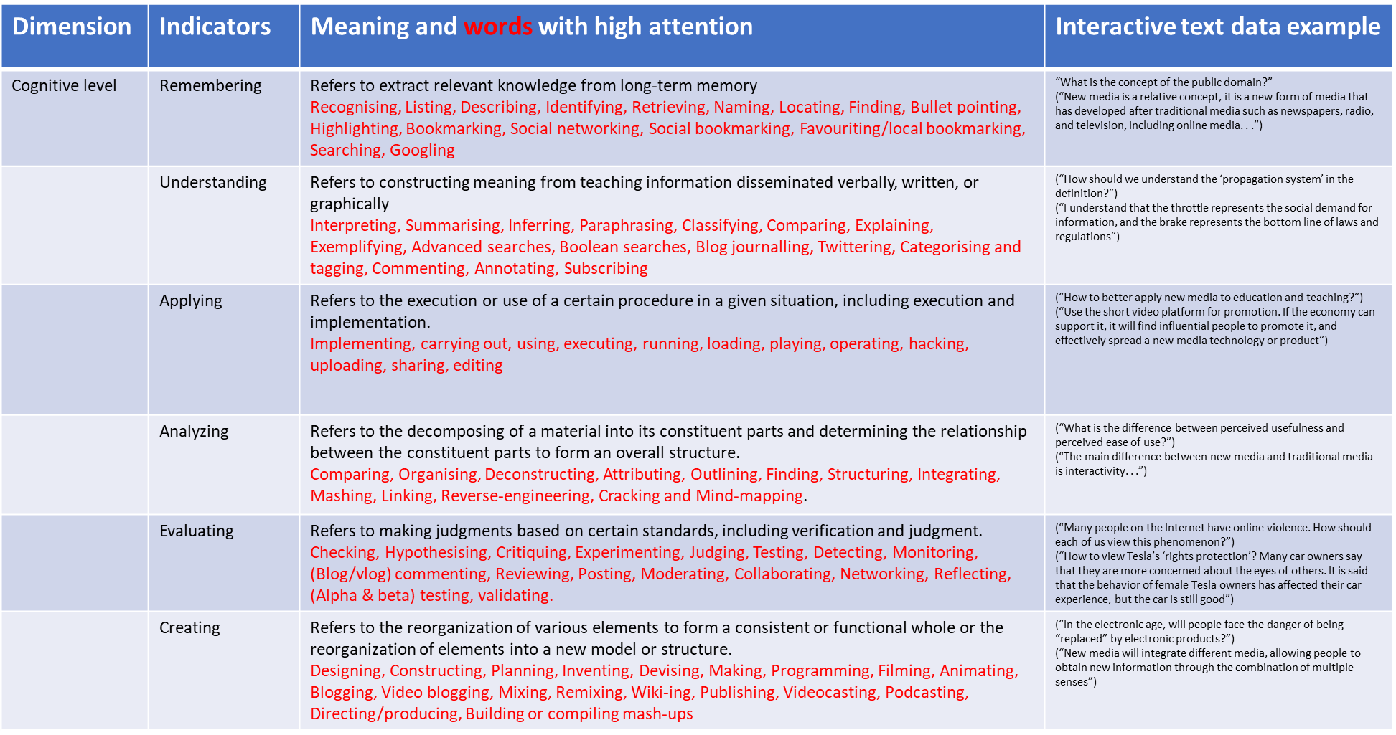

[5] A Taxonomy For Learning, Teaching, And Assessing Lorin W. Anderson And David R. Krathwohl Peter W. Airasian, Kathleen A. Cruikshank, Richard E. Mayer, Paul R. Pintrich, James Raths, Merlin C. Wittrock
[6] A Cognitive Level Evaluation Method Based on a Deep Neural Network for Online Learning: From a Bloom’s Taxonomy of Cognition Objectives Perspective Yan Cheng1*, Yingying Cai1,2, Haomai Chen3, Zhuang Cai1, Gang Wu1 and Jing Huang1
[7] Hidayat, F. Andrew Churches - Bloom's Digital Taxonomy.pdf

Operational Coding for Cognitive Process Dimension
- Chunking has been done for conversations.
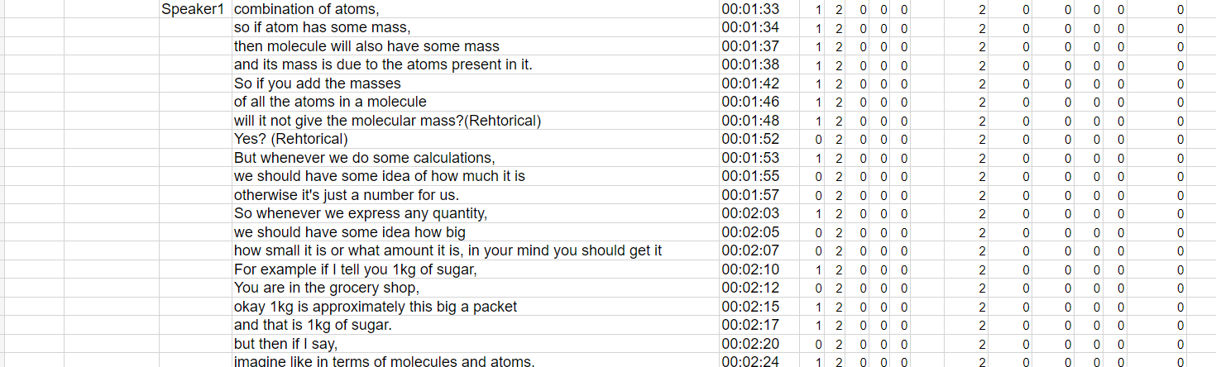
- Class should not matter while deciding which cognitive process is taking place. Meaning the action of a student should determine the cognitive process that is occurring in the present, rather than their prior knowledge. Since Understanding involves transfer rather than just retention, we should go with understanding here rather than remembering. Although partial remembering (remembering while recalling an atom) may be occurring, since transfer is happening, we will recognise that a higher cognitive dimension, like Understanding, is taking place here. This is a very important rule, as we always encode what cognitive process is finally taking place. For example, while students are “applying”, they must be using words which require “remembering” or “understanding”, but in these cases, also since focus is on “applying”, cognitive process, the lines should be encoded as “applying”.
- The above chunk has been marked as Understanding by taking the hint from the occurrence of Conceptual knowledge. The rule is that, when the teacher is only speaking conceptual knowledge, and students are just listening, then in these scenarios, we call it “understanding” only by assuming students must be doing “interpretation”, “summarising”, “explaining”, etc., in their brains. But if a question is asked and answered by students, then we have to be careful about the cognitive process type.
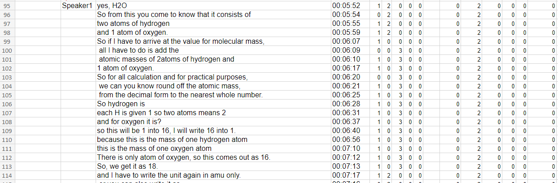
- Above are some examples of “remembering” that occurred between the lines of “understanding”.
- Above is the example where “Understanding-Procedural Knowledge” was occurring (lines 100-112). Although in these lines, the teacher is teaching the steps involved in calculating the atomic mass of water molecules, students are not actually doing the steps. They are just listening and understanding these steps. This conclusion has been drawn from watching the video, and also the global encoding (teaching) gives us a hint regarding the occurrence of understanding only.
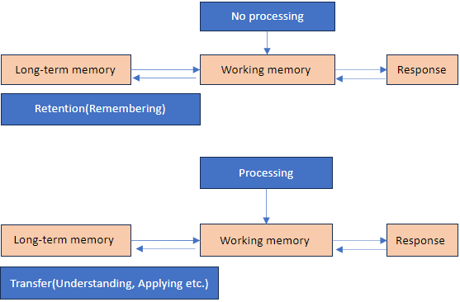
- Although here the teacher is asking a “what-mean” question, it may give the impression that the teacher is trying to prompt students to “understanding,” but if we check the Video of the transcribed lines, it is quite sure that the teacher is asking this question just to ensure that students remember how many things are there in a “dozen” rather than teaching them the concept of “dozen.” Hence, here, we are inferring from the teacher’s intent rather than strictly going by the wording used by the teacher. So, lines (red) were marked as “remembering.”
- Note: Retention cognitive process (Remembering: Recognising involves retrieving relevant knowledge from long-term memory in order to compare it with the presented information. In recognising, the student searches long-term memory for a piece of information that is identical or extremely similar to the presented information (as represented in working memory). Recalling involves retrieving relevant knowledge from long-term memory when given a prompt to do so. The prompt is often a question. In recalling, a student searches long-term memory for a piece of information and brings that piece of information to working memory where it can be processed) involves retrieving/searching relevant knowledge from long-term memory and then bringing that piece of information to “working memory” and the question is answered without processing on that information. In the case of the transfer cognitive process (understanding, applying, etc.), generally, we bring a piece of information from our long-term memory to working memory and then do processing before answering the question.
- As we can see, since in the “knowledge dimension” we have kept the chunking, the same thing has been reflected in the “cognitive dimension” because it has been argued that for 2-3 lines that are occurring in between the teaching when teacher delineates from the content or topic we should keep these lines as part of chunking or conversation because it will not make much sense to break the chunking for every small off-topic remark. In cases where teachers digress from the topic for a long time (or for lines more than 3), we used to break the chunking. Most of the time, when there is no “Knowledge dimension” occurring, it is a strong indication that no “cognitive dimension” is occurring. But in some exceptional cases, cognitive dimension chunking can be kept on if the coder thinks it would not be wise to break the chunking for 2-3 lines while encoding the cognitive dimension. This flexibility has been given by assuming that these small scenarios should not affect the overall percentage agreement between coders.

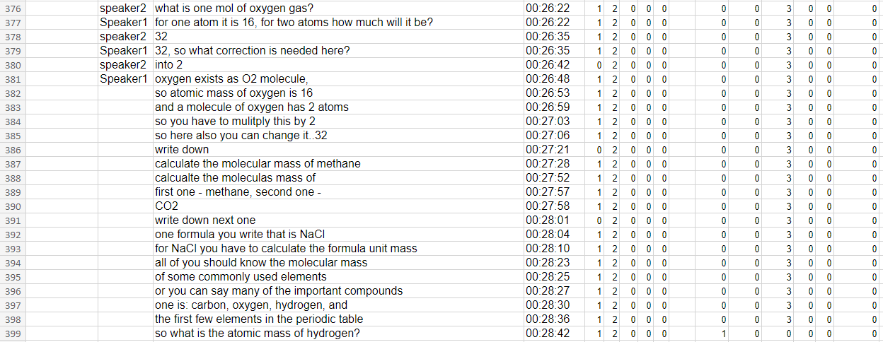
- Above are some examples where no cognitive dimension has been marked because the teacher digressed from the topic for a long time, and the hint is taken from the knowledge dimension columns, as no knowledge dimensions are present.

- Above is the example where “applying-conceptual knowledge” is occurring. This has been called “applying” rather than “understanding” because after seeing the video, it is evident that although the teacher was telling students how to solve the question, students were solving/applying the steps with the teacher.
Cognitive Process dimension | Corresponding Knowledge dimension | Corresponding Global dimension
Remembering | Factual | Preassesment
Understanding | Conceptual | Teaching
Applying | Procedural | Assessment

- Note: Global encoding and Knowledge dimension both can be used to get an idea about which cognitive process dimension is occurring. As a general rule of thumb, the following observations can be used.
But always keep in mind that this is not necessarily always the case and coder should not rely on the above rule alone. In case of confusion the decision should be made after watching the video and figuring out the intent of the teacher. Also, in scenarios where it is not possible to figure out the intent of the teacher, multiple cognitive dimensions can be encoded.
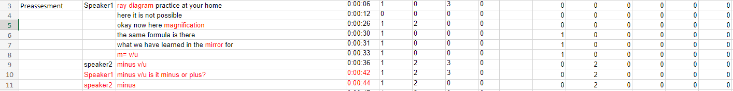
- In line 8, the teacher intentionally said the wrong thing, and students are correcting him. This seems to be an instance of “Evaluating” (Checking), but we decided that we will call an occurrence “Evaluating” only when a student is not only doing something wrong but also telling why and how it is wrong. This means that either the student is telling internal fallacies on the basis of some criteria or standard, etc., or bringing external criteria or standards to answer a question, only then will we call it “Evaluating.” Simply saying something wrong or correcting something will not create an instance of “Evaluating.” Since in line no. 9 student is correcting the intentionally spoken wrong formulae by the teacher, it has been decided that such instances should be marked as “Understanding (comparing)” rather than “Evaluating” (Checking). Also, in lines 10-11, where the teacher asks students questions involving “or presents students with questions which demand students to choose among two options or make the distinction between things, and in response to that student just chooses one option, it was decided to encode these lines as “Understanding” rather than going all the way to call these judgements as “Evaluating’.

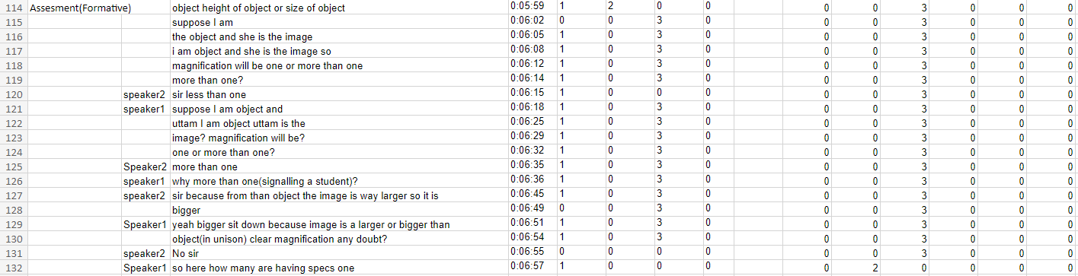
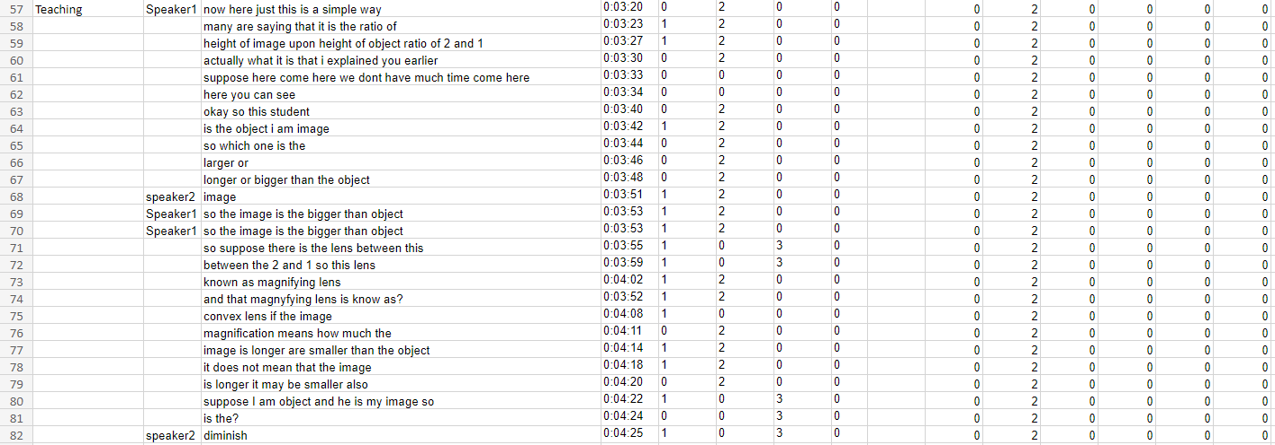
- In this type of class, where the teacher does not follow the standard way of teaching where the teacher first does “Preassesment,” then “Teaching,” and then “Assessment” in this order for the whole class but rather he/she is switching between above three global encodings types it becomes very subjective to decide when “understanding” is ending and when “applying” is getting started or there is no “applying” altogether and everything is part of “understanding.” In these scenarios, it was decided to take help from global encoding because during the “teaching” type of global encoding, generally, the teacher’s intention is to make the student understand rather than apply. Whereas during “assessment” type of global encoding, the teacher’s intention is to ask students such questions where students have to apply the knowledge they have just learned or have learned earlier. This makes global encoding an important source of information that will help us identify the type of cognitive process dimension in these subjective scenarios. Hence, despite the similarity between examples 1 and 2 shown above, after taking hints from watching the video and global encoding, it was decided to encode the lines that belong to “teaching” global encoding as “understanding” and the lines that belong to “assessment” as “applying”. Note that in both cases teacher is asking questions to the student, but it was argued that in the case of “teaching,” the intent of asking questions to the student is to make them understand the knowledge, which is the reason the questions actually ask student to do “comparing”, “interpreting” or “exemplifying” etc. But for 2nd case, the teacher wants students to apply the knowledge that they have just learned.
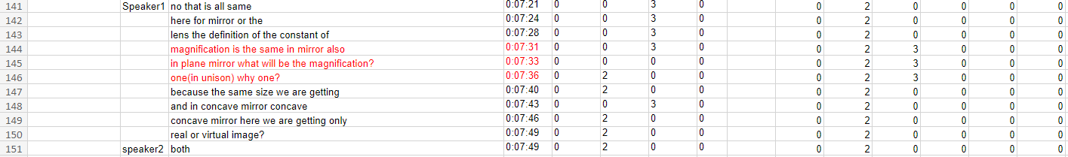

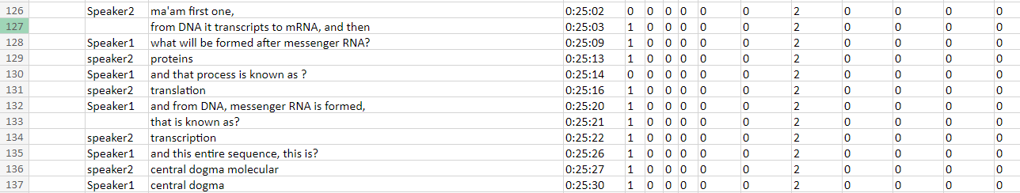
- In the first case (red lines) was a special case where, although the intention of the teacher seems to make the students understand (because global encoding is “teaching”) but to answer the question, students not only have to do “understanding (exemplifying)” but also, they have to do “applying” to calculate the magnification of the plane mirror. Hence, in these cases, it is acceptable to encode these lines as both “understanding” and “applying.” Similarly, lines (227-229) give the impression that it should be marked as “understanding,” but since the concept of the mole has been taught, and now the teacher is asking questions about the number of atoms present in 1 mole of the carbon atom, it has been argued that to answer this question students have to apply the conceptual knowledge and hence “applying” is occurring. Note: According to Rule 2, we should encode only the final thing, but in cases mentioned above, since another cognitive dimension is occurring just for 2-3 lines, it would not be wise to break the original chunking of the cognitive process (“understanding” in cases 1 and 2). Hence, we kept the original chunking of “understanding” in both cases as well.

- The above lines were taken from a biology class, and the global encoding type was “assessment.” In biology classes, even in the case of “assessment,” global encoding type generally “understanding (interpreting, comparing, exemplifying, etc.)” occurs because students have to answer questions that involve “understanding” rather than “applying”.

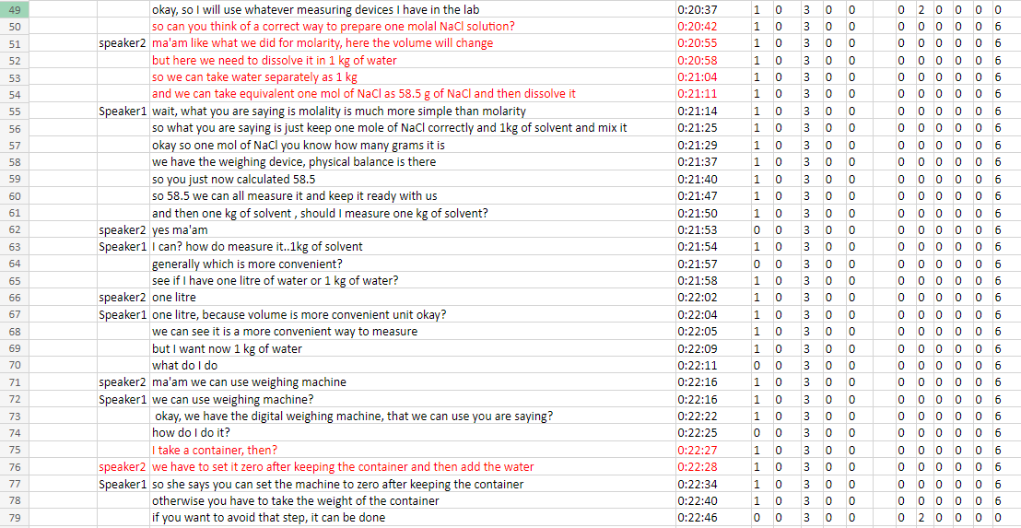
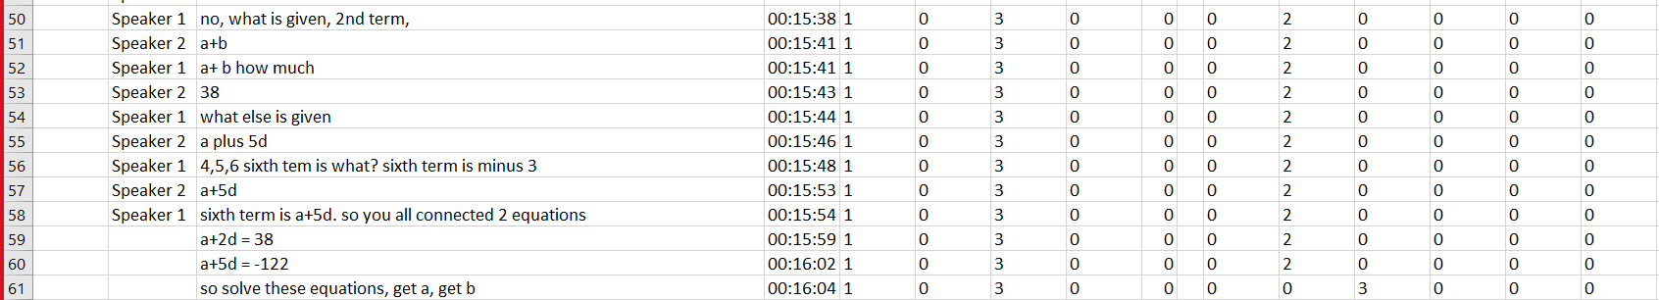
- In the above example, lines 50-60 have been marked as “understanding (interpretation)” because, in this chunk (which was a prelude to solving the question given on the board), students are quite visually answering the questions using “interpretation”. Since this chunk is a bit large, it would not be prudent to start the “applying” chunk from line 50. This scenario was a bit special as assessment got started, but before actually starting to solve the question, the teacher is making the student understand the question through the “understanding” (Interpretation) cognitive dimension. So, we have to be careful in the “assessment” section as to when to start encoding the “applying” cognitive dimension.

- The above lines (50-78) are an example of Create (planning). In this example, the teacher asked students to devise a method to prepare a one molal solution in the lab. In further conversation, the teacher gives hints to students to better plan the method with all the intricacies involved in devising this experiment. Hence, this whole conversation is marked as “create”.
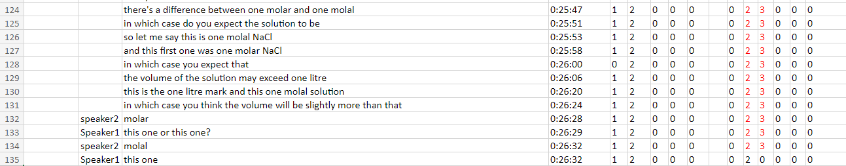
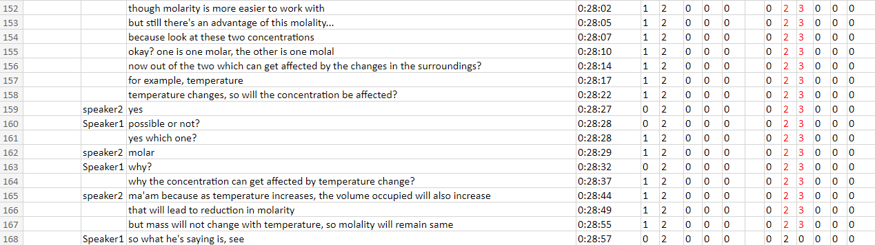

- The above two scenarios are examples of cases where the teacher is asking a question that requires students to think critically and apply their prior knowledge in a new scenario related to the topic the teacher is teaching. It seems that to answer these questions, students are using “understanding (comparing)” and then “applying (executing)”. Since it is hard to separate in these instances, all lines have been marked as both“understanding” and “applying”. There was a discussion on whether this scenario should be marked as “analysing (differentiating)”, but after seeing the video, it was evident that students are applying the knowledge using understanding rather than analysing the scenario.

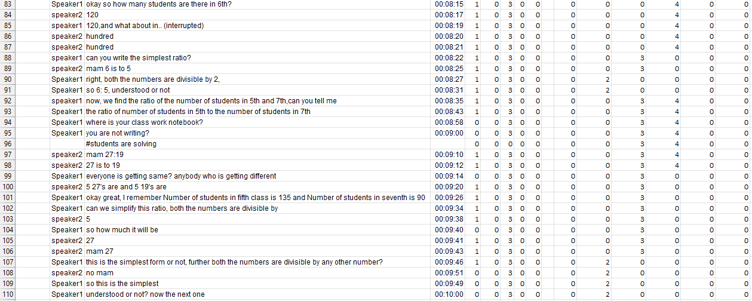
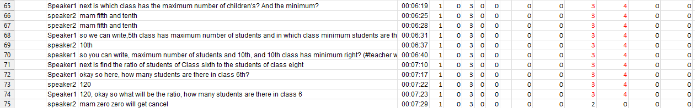
- The above cases are examples of “analysing (differentiating)”. For “data interpretation” questions where students have to look at the data given in the question and decide which information is relevant or irrelevant to answer a certain question, students must be doing “analysing (differentiating).” Cases (lines 83-87) where students are just stating relevant information have been marked only “analyzing” and instances (lines 65-74, 92-98) where students are also using the relevant information to answer the question have been marked as both “applying” and “analyzing” as it is hard to separate them in these instances. The instances where the teacher is explaining the steps and students are doing the steps and calculating the answer have been marked as “applying” (lines 88-89, 99-106 ). The instances (lines 90-91, 107-110) where the teacher is summarising what they have done are encoded as “understanding.”

Remembering
- Factual knowledge(chem_tr_10_08)

- Conceptual knowledge (exp6_6th_sci_svs_1_08_cognitive_Vivek)
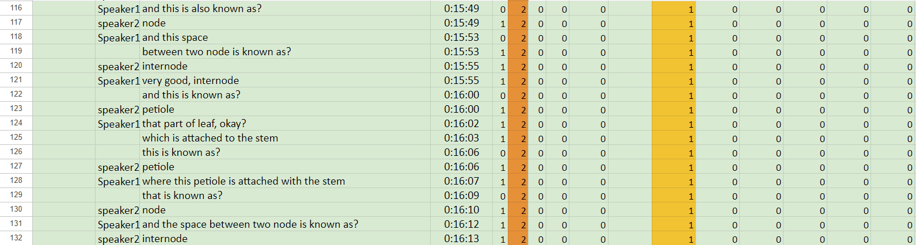

- Procedural Knowledge
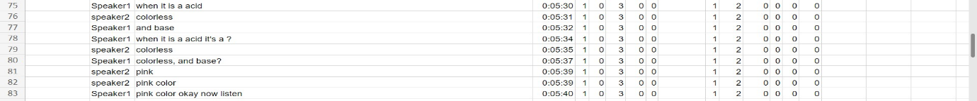

- Metacognitive Knowledge

Understanding
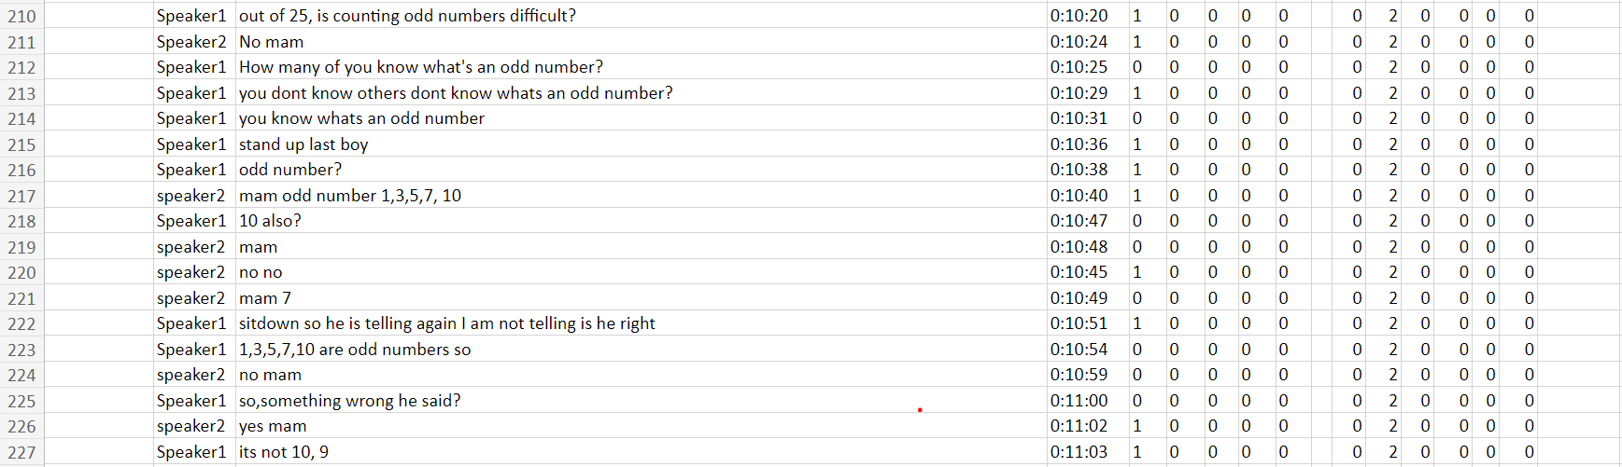
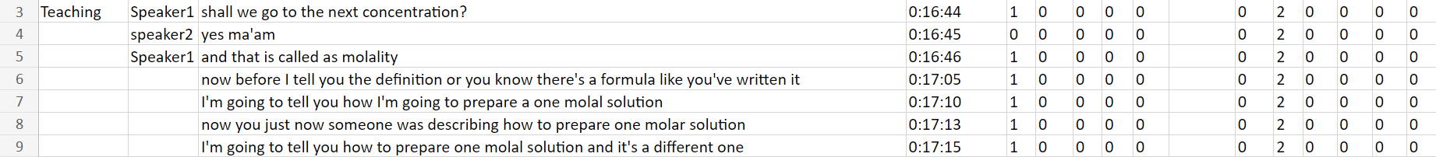
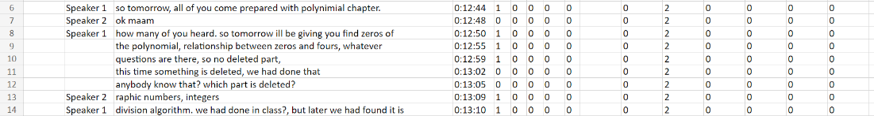
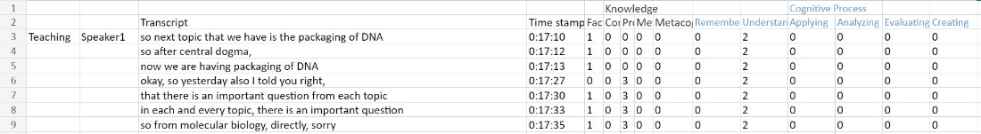
- Factual Knowledge (10svs1_21_07_2022; 20220718_102308_10a_ah_math; exp3_chem_tr_08_17; exp8_20220726_133023ah_6a_Maths)

- Conceptual knowledge (exp_3_chem_tr_18_07_cognitive_vivek)

- Procedural Knowledge (exp_3_chem_tr_18_07_cognitive_ant)
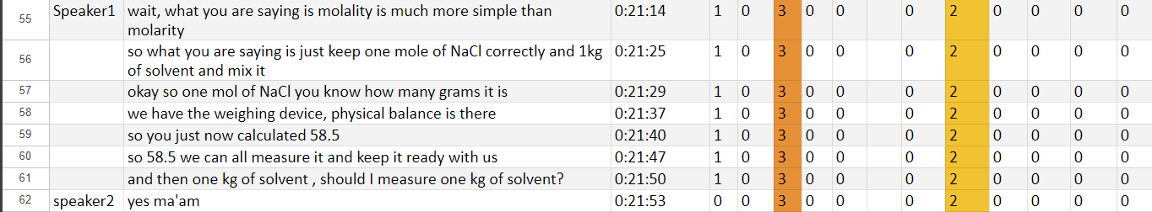
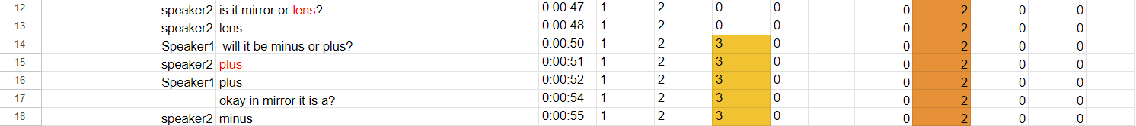
  - (all2_transcript_episode_1_21_07_2022_aman_viv_ant)

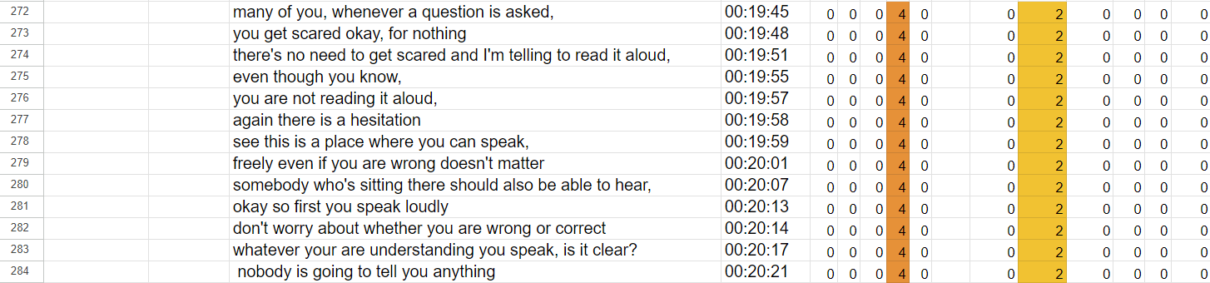
- Metacognitive Knowledge (all3_chem_tr_10_08)
- (exp2_20220718_102308_10a_ah_math_expclip_vivek)

Applying
- Factual Knowledge (exp3_chem_tr_08_17)
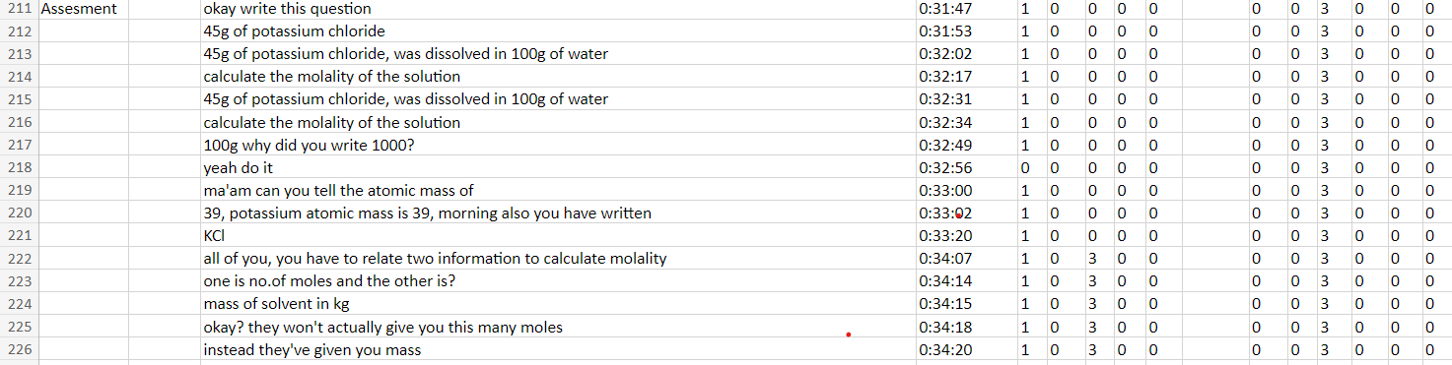

- Conceptual knowledge (chem_tr_10_08, exp2_20220718_102308_10a_ah_math)
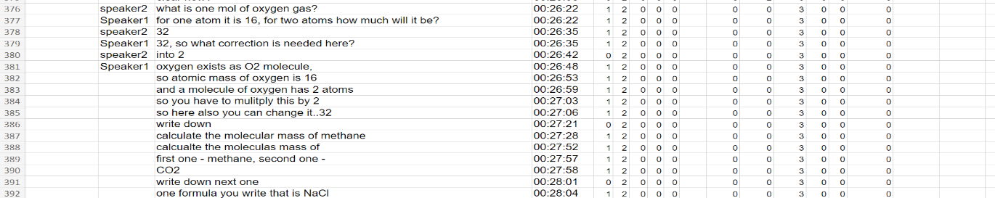

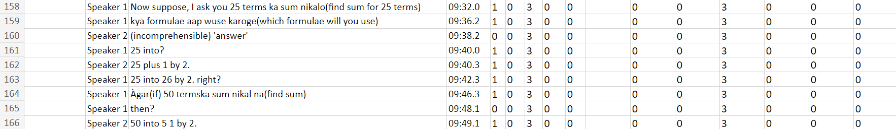
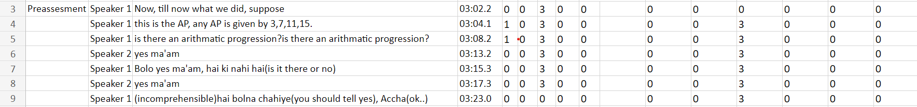
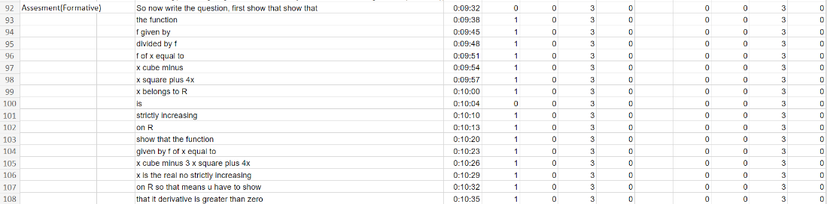
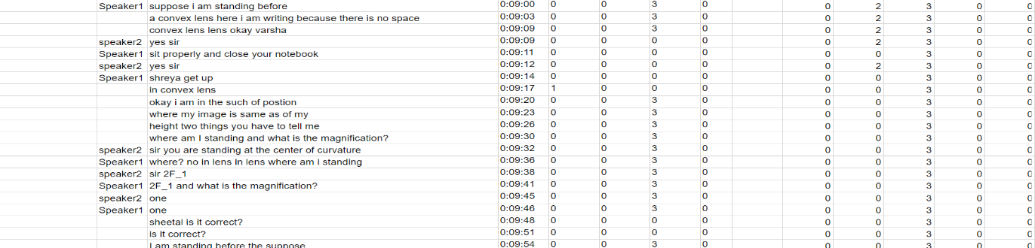
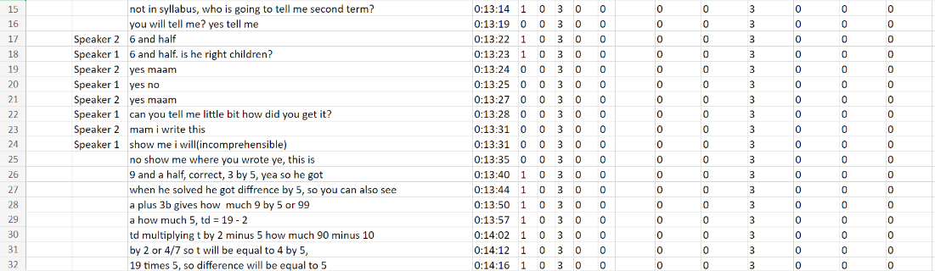
- Procedural Knowledge (10svs_21_07_2022, exp4_17_08_math_12; exp8_20220726_133023ah_6a)

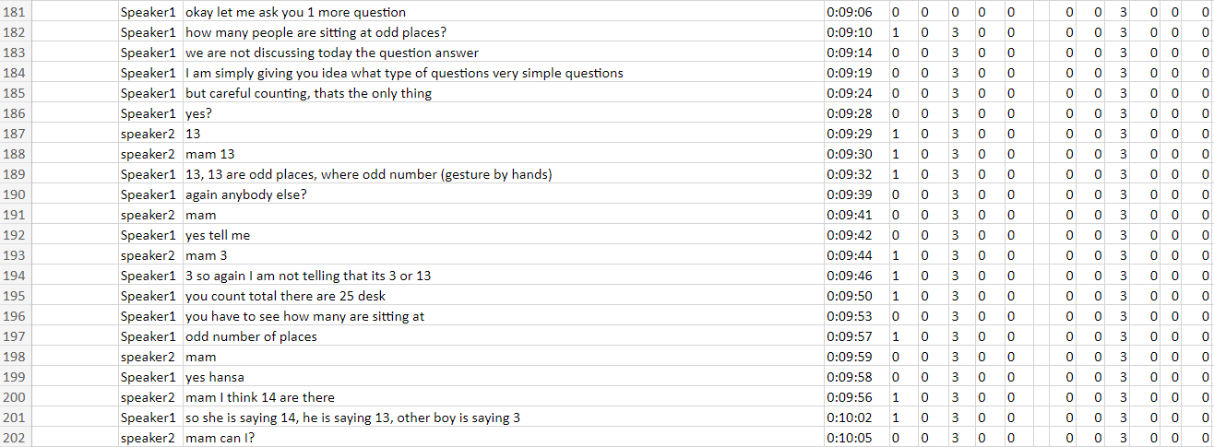
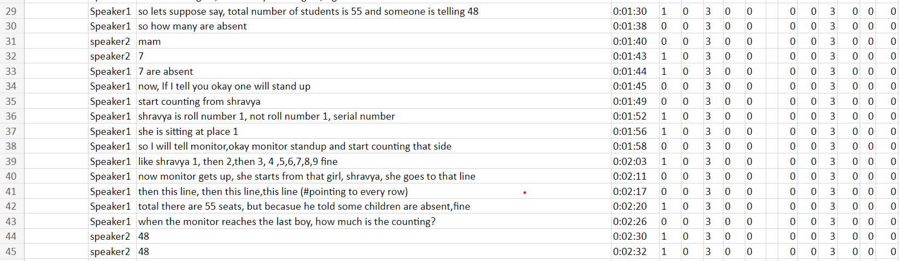
- Metacognitive Knowledge (exp9_20220726_133023ah_6a_Maths)

Hybrid cases
  - Remembering + Understanding
  - Remembering + Applying

  - Understanding + Applying

Type of rules | Remembering (Rem) | Understanding (Und) | Applying (App) | Analysing (Ana) | Evaluating  (Eva) | Creating (Cre)
Decision rules | Utterance involving recall or recognition without transfer | Utterance demonstrating construction of meaning through explanation, interpretation, or categorisation. | When procedures are executed or implemented in a given situation | Utterance involving breaking material into parts and examining relationships or structure | Utterance involving judgment based on criteria or standards. | Utterance involving generating new ideas, products, or reorganised structures
Inclusion criteria | - Direct retrieval of facts, terms, or labels, etc.  - Small response time  - The presence of FK is taken as a strong indicator of the Rem. | - Explaining ideas, paraphrasing content, classifying examples, or illustrating meaning  - The presence of CK is taken as a strong indicator of the Und. | - Use of rules, formulas, methods, or procedures to solve a problem or perform a task  - The presence of PK is taken as a strong indicator of the App. | Comparing components, identifying relationships, organising ideas, or distinguishing relevant from irrelevant information | Justifying decisions, critiquing arguments, testing claims, or reflecting on correctness or quality. | Designing, constructing, planning, inventing, or proposing novel solutions or representations.
Exclusion criteria | If the retrieved information is articulated using one’s own words | Mere recall of facts (Remembering) or use of knowledge to perform a task (Applying) | Explanation of procedures without execution (Und) or justification of method choice (Ana/Eva) | Explanation without decomposition (Und) or judgment without analysis (Eva) | Analysis without judgment (Ana) or creative proposal without justification (Cre) | Modification or application of known solutions without originality (App/Ana)
Boundary conditions |  | - Listening to or taking notes on different types (CK, PK, MK) of knowledge  - Intentional use of incorrect statements by the teacher to elicit correction is coded as Und | - Based on intent inferred from “Assessment” (global encoding) question–response interactions are coded as App  - Interpreting-PK cases encoded as Und rather than App | Data interpretation questions that require distinguishing relevant from irrelevant information | Correcting incorrect statements with an explanation is coded as Eva | Planning a method to do an experiment
  Responses limited to recall were coded as Rem, irrespective of response time
Hierarchical priority rules | Lowest priority among cognitive processes | Overrides “Rem” but is overridden by “App” or higher processes if present | Overrides “Rem” and “Und” | Overrides “App” and all lower processes | Overrides “Ana” and all lower processes | Highest priority; supersedes all other cognitive process codes if present

